23CSE111 OBJECT ORIENTED PROGRAMMING
S2 B.Tech CSE
Department of Computer Science and Engineering
Amrita School of Computing, Amritapuri Campus
CASE STUDY
PHASE – 2 (Design)
Architectural Modelling (CO2)

Group No : C11
Team Members :
Roll No | Student Name
AM.SC.U4CSE25201 | Akshanya S
AM.SC.U4CSE25229 | Krishna Jayakumar
AM.SC.U4CSE25246 | Sanjana S
AM.SC.U4CSE25259 | Yaksh Chauhan

- Problem Title : University Hostel Management System

STRUCTURAL DESIGN
- Class diagram
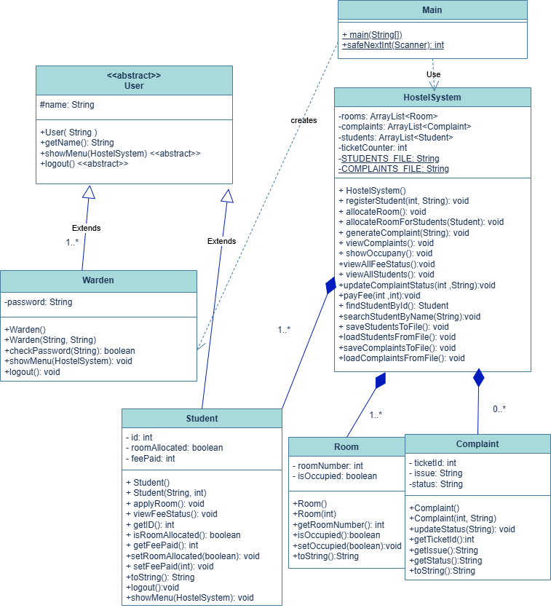

BEHAVIUORAL DESIGN
- Use-case diagram
- List of actors
- Student
- Warden
- List of use-cases

Use-cases of Student:

- Apply for Room: The student requests a hostel room, and the system checks availability. If available, a room is assigned and the student’s allocation status is updated. Otherwise, the student is notified about the unavailability of rooms.
- View Fee Status: The student can check their fee payment status along with payment history to maintain a track of their payments
- Pay pending Amount: If the student wishes to pay the pending fees, he/she may pay the fee and this action will be updated in the fee record.
- Lodge Complaint: If any student wishes to lodge a complaint, he/she may do so. This will result in a unique ticket ID generation and the system creates a new record with default status as “Open”.
- Generate ticket ID: The system assigns a unique ID to each complaint automatically. This ID helps in tracking and managing complaints. It ensures every complaint is distinguishable.
- Track Complaint status: The student can use this unique ticket ID to view the status of their complaint. The system displays whether it is Open, In Progress, or Resolved. It keeps students informed.
- View “Pending”: Indicates the complaint has been registered but not yet addressed. It is the default initial state. The student knows the request is pending.
- View “In Progress”: Indicates that the complaint is actively being worked on by the admin. It reassures the student that action is being taken. This status is updated by the system.
- View “Resolved”: Indicates the student that the complaint has been successfully fixed. It marks the completion of the issue.

Use-cases of Warden:
1. Register Student (registerStudent()): Adds a new student record to the system. Validates student ID before saving. Prevents duplicate registrations.
2. Validate Student ID (searchStudentByName()): Checks if the given student ID already exists. Ensures uniqueness of each student. Flags duplicate IDs if found.
3. Allocate Room (allocateRoom()) : Assigns a room to a registered student. Ensures room is available before allocation. Updates room status after assignment.
4. Check Room Availability (isOccupied()) : Verifies whether a room is already occupied. Returns availability status (free/occupied). Helps avoid double allocation.
5. Mark Room Occupied (setOccupied(true)): Updates room status to occupied. Triggered after successful allocation. Maintains accurate occupancy records.
6. Show Occupancy (showOccupancy()): Displays current room occupancy details. Provides count of occupied rooms. Helps monitor hostel usage.
7. Display Room Count (getRoomNumber()): Retrieves total number of rooms. Shows number of available vs occupied rooms. Used in occupancy reporting.
8. View Fee Status (viewFeeStatus()): Allows viewing of individual fee details. Shows paid, pending, or overdue status. Accessible by student or admin.
9. View All Students' Fees (viewAllFeeStatus()) : Displays fee status of all students. Helps warden track payments. Useful for financial management.
10. View Complaints (viewComplaints()) : Shows complaints submitted by students. Accessible to both warden and student. Helps track issue history.
11. List All Complaints (viewComplaints()): Displays complete list of complaints. Organized for easy monitoring. Used by warden for management.
12. Update Complaint :Allows modification of complaint status. Marks progress (e.g., in-progress/resolved). Keeps complaint tracking updated.

- Use case diagram
- 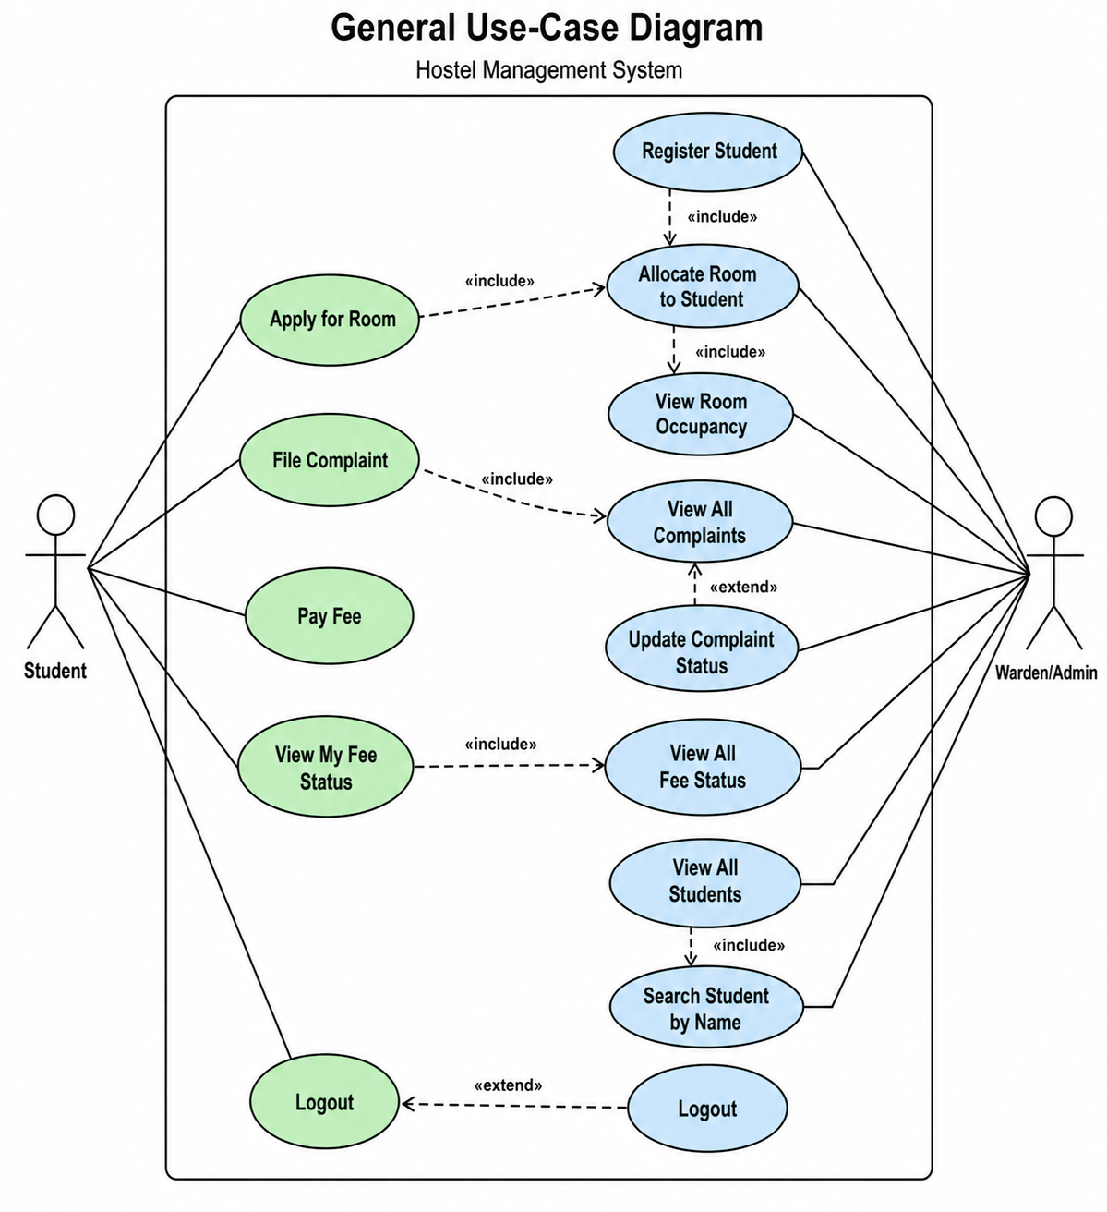

- Sequence diagram
1: Student Operations
Scenario: A student logs into the hostel management system using their ID. After successful verification, the student can apply for a room, pay hostel fees, file complaints, and view their fee status. The system processes each request by interacting with Room and Complaint classes and provides appropriate responses such as room allocation confirmation, payment success, or complaint ticket ID.
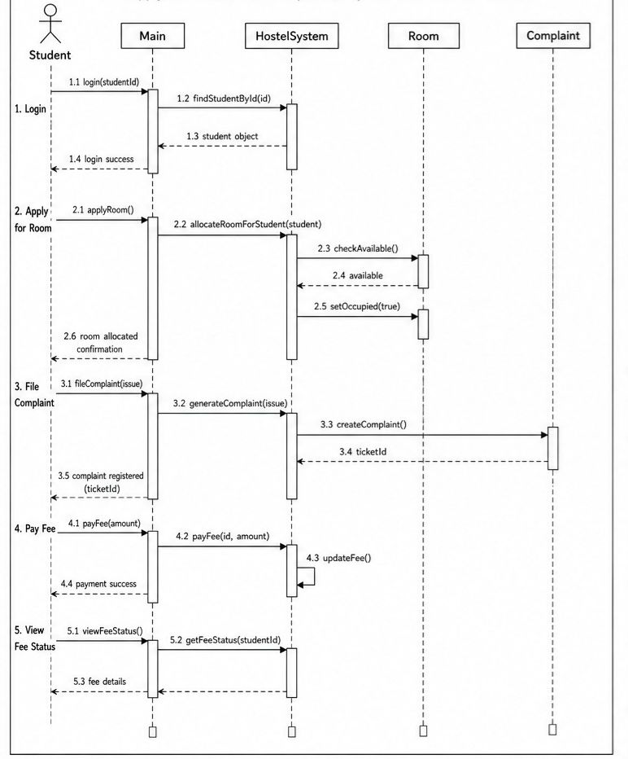

2: Warden Operations
Scenario: The warden logs into the system using a password. After authentication, the warden performs administrative tasks such as registering new students, allocating rooms, viewing complaints, updating complaint status, and checking reports like student details and fee status. The system updates records and manages data accordingly.
